FOR IMMEDIATE RELEASE  Date: October 2, 2018 | Media Contact: George B. Flood  Tel: 732-819-3669  Email: george.b.flood@usps.gov  usps.com/news
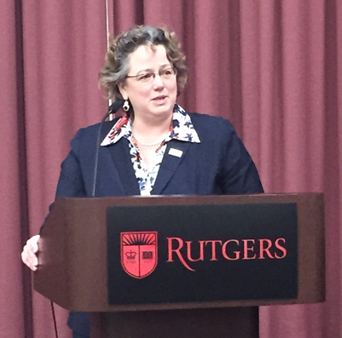

Postal CIO Talks Innovation at NJ Mailing Industry Meeting
NEW BRUNSWICK, NJ –The Postal Service’s Chief Information Officer / Executive Vice President Kristin Seaver gave the keynote presentation at the Greater New Jersey Postal Customer Council (PCC) on Wednesday, September 26 at Rutgers University’s Cook Campus Center in New Brunswick. The CIO highlighted the Postal Service’s business strategies for building a successful future through technology, innovation, and partnership with the mailing industry.

The New Jersey meeting was one of nearly 150 Postal Customer Councils that held events nationwide during National PCC Week 2018. Composed of professional postal and mailing industry managers, the nationwide PCC network is designed to foster a close working relationship between the U.S. Postal Service and commercial mailers.

The six hour forum at Rutgers began with an early morning networking session. Attendees visited information booths and exhibits with industry professionals showcasing the latest in mailing systems, products, services, and high-tech innovations. One of the key exhibitors, Anchor Software, was a gold level sponsor for the September 26 meeting. Postal Inspectors also manned an information table sharing valuable crime prevention and mail security tips.

The formal presentations began with opening remarks from Greater NJ PCC Industry Co-Chair / Millennium Group Inc. Manager Lauran Solvik and Greater NJ PCC Postal Co-Chair / U.S. Postal Service Northern NJ District Manager Eric Henry.

In addition to showing a special videotaped message from Postmaster General Megan Brennan, the Postal Chief Information Officer / Executive Vice President highlighted two innovative initiatives: Informed Delivery and Informed Visibility. Informed Delivery is a free service that offers consumers the convenience of seeing what is coming to their mailbox – anytime, anywhere – even while travelling. Informed Visibility is an online system for mailers that provides near real-time information and insights into their mailings.

Ms. Seaver concluded her presentation with a lively question and answer session; then presented the Greater NJ PCC Executive Board with Platinum / Gold Premier Awards for implementing best practices to create business growth opportunities for PCC members and the U.S. Postal Service.

Dovetailing into the CIOs remarks, Postal Service Sales Executive Gary Johnson and Operations Integration Specialist Robert Chisholm gave a workshop on leveraging the data from the Informed Visibility dashboard, which dovetailed.

James Lombard, Greater NJ PCC Executive Board Member / Universal Mailing Service Director Marketing and Sales, gave an enthusiastic overview of a new innovative PCC Academic Outreach Program. PCC members nationwide are reaching out to local colleges and universities to develop relationships with their marketing and graphic communications departments. Lombard emphasized the goal is to educate professors about how direct mail coursework can enrich their curriculum and inform students about the power of direct mail in an integrated Omni channel marketing campaign — both from a marketing and graphic communication perspective.

###
Photo Caption: U.S. Postal Service Chief Information Officer / Executive Vice President Kristin Seaver talks innovation at the Greater NJ PCC Week Meeting at Rutgers.

